Stack vs heap

**Stack:**

1. Push / pop variables
2. Managed and optimized by CPU ( stack fits the local CPU cache)
3. LIFO
4. Very fast
5. Limited size of stack
6. Variables are allocated and freed automatically
7. Separate for each thread

**Heap:**

1. Free-floating region of memory ( not a tighly managed by CPU )
2. Variables can be accessed globally
3. Larger than stack
4. Slower access
5. Memory managing by own

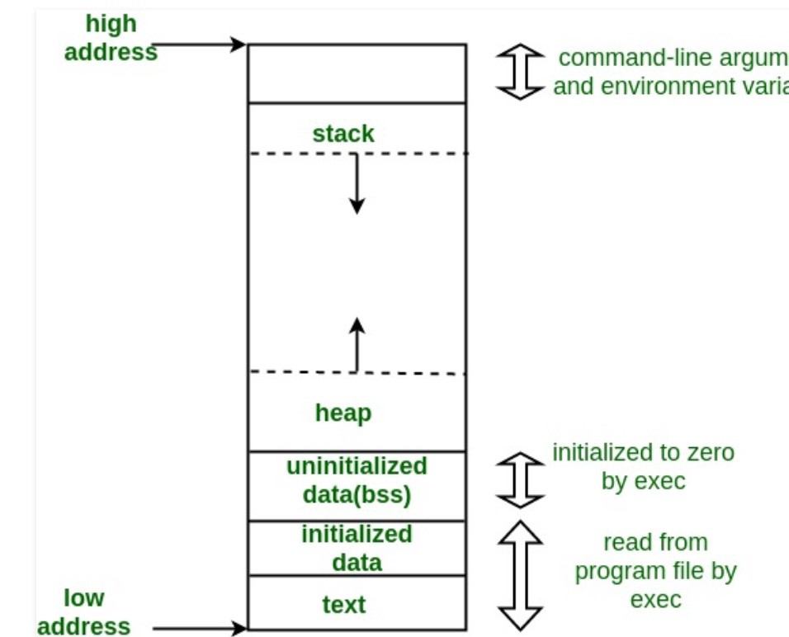

The initialized data segmentconsists of all the global and static variables that are initialized when a file gets compiled. The uninitialized data segment consists of all global and static variables that are initialized to zero or do not have explicit initialization in source code.

The text segment, also known as the code segment, contains the machine instructions which make up your program. The text segment is often read-only and prevents a program from accidentally modifying its instructions. Section of the program's [virtual address space](https://en.wikipedia.org/wiki/Virtual_address_space) that contains [executable](https://en.wikipedia.org/wiki/Executable) [instructions](https://en.wikipedia.org/wiki/Instruction_(computer_science))